Zero Trust Network Access (ZTNA) with Zscaler: Securing User-to-Application Connectivity.

Zero Trust Network Access (ZTNA) with Zscaler: Securing User-to-Application Connectivity

Team ID: SWTID-2026-5115
Team Size: 4
Team Leader: Arun prasad G
Reg No:2322K2454
Email: arunarun17542@gmail.com
Team member: Praveen kumar R
Reg No:2322K2468
Email: praveen739775@gmail.com

Team member: Nithish kumar S
Reg No:2322K2466
Email: nk6034011@gmail.com

Team member: Ajith Kumar.S
Reg No:2322K2452
Email: black444ajith@gmail.com

College Name: Sri Ramalinga Sowdambagai College Of Science And Commerce
College Code: bru3y

INTRODUCTION:

In today’s rapidly evolving digital landscape, ensuring secure and trustworthy user interactions has become more challenging than ever. Traditional security methods, such as passwords and two-factor authentication (2FA), are no longer sufficient to combat increasingly sophisticated cyber threats. Attackers now exploit stolen credentials, phishing techniques, and social engineering tactics to bypass static security measures.
AI-Enhanced User Protection (AIUP) represents a new generation of security frameworks designed to address these challenges. By leveraging artificial intelligence and machine learning, AIUP continuously monitors and analyzes user behavior to establish a dynamic “trust score” for each individual. Instead of relying solely on what users know or possess, AIUP focuses on who they are—based on behavioral patterns such as typing speed, device usage, location, and interaction habits.
This continuous and adaptive approach enables organizations to detect anomalies in real time, prevent unauthorized access, and significantly reduce the risk of fraud. As a result, AIUP provides a more robust, intelligent, and proactive layer of security, making it an essential solution for protecting modern online platforms.
Abstract:
The limitations of legacy VPN architectures in addressing modern security threats, particularly lateral movement and over-privileged network access, necessitate a paradigm shift towards Zero Trust principles. This project details the comprehensive design, deployment, and management of a Zero Trust Network Access (ZTNA) solution leveraging Zscaler Private Access (ZPA) within a largescale institutional network. The project aims to replace broad network-level access with application-specific, identity-driven connectivity. By deploying Zscaler App Connectors within the data center and integrating the platform with existing Identity Providers (Azure AD) and endpoint security tools, the architecture ensures that all user-to-application connections are established through a cloud-native broker. This approach renders internal applications "invisible" to the internet, eliminating the attack surface. Furthermore, the project explores the integration of Zscaler with security ecosystems, including SIEM platforms (like QRadar) for centralized logging and MISP for consuming threat intelligence to enable adaptive access policies. The result is a robust, scalable security framework that enforces least-privilege access, provides comprehensive audit trails, and significantly enhances the institution's resilience

Use Case Scenarios:
Scenario 1: Secure Remote Access for Faculty to ERP System
A faculty member working from home needs to access the university's ERP system to upload student grades. Using Zscaler Private Access (ZPA), they connect securely without being placed on the internal network. The system verifies their identity via Azure AD MFA and checks their device posture before granting access.
Scenario 2: External Researcher Accessing a Specific Database
An external research collaborator from another institution requires temporary access to a single research database hosted on VIT's servers. The administrator creates a time-limited, application-specific policy in Zscaler. The researcher accesses only the authorized database without any visibility into the rest of the VIT network.
Scenario 3: Student Access to Online Examination Portal
During final exams, thousands of students simultaneously access the internal online examination portal from various locations. Zscaler ZPA ensures that only authenticated students with compliant devices can reach the exam server. The system prevents DDoS attacks on the login page and blocks any attempts to access other internal resources.
Scenario 4: IT Administrator Performing Server Maintenance
An IT administrator needs to perform critical updates on an internal application server. Instead of connecting via VPN and gaining full network access, they use ZPA to connect directly to the specific server's management interface. The session is monitored in real-time, and any anomalous behavior (e.g., accessing unauthorized servers) is automatically terminated.
Scenario 5: Mergers and Acquisitions – Temporary Contractor Access
A contractor hired during a university system upgrade needs temporary access to a specific file server to migrate data. Using Zscaler ZPA, the contractor is granted application-specific access without being added to the university's Active Directory or given VPN credentials. The access is revoked automatically after the project timeline.

Stage-1
Tital:
Zero Trust Network Access (ZTNA) with Zscaler: Securing User-to-Application Connectivity.
Overview: -

Here’s a concise version of your content:

Project Summary
The project aims to develop an AI-driven identity verification system that enhances online security by analysing user behaviour patterns. Using advanced machine learning techniques such as deep learning, neural networks, and natural language processing, the system builds dynamic behavioural profiles to distinguish legitimate users from suspicious activities.

It features real-time anomaly detection to identify unusual behaviour and respond quickly to potential threats. Multi-factor verification is triggered when anomalies are detected, along with alerts for users and administrators to ensure transparency and prompt action.

The system also includes secure data storage, encryption, and compliance with privacy regulations to protect sensitive information. It supports seamless integration with online platforms, along with monitoring and reporting for performance and security.

Designed for scalability, the system incorporates load balancing, optional cloud infrastructure, and continuous model training to adapt to evolving threats. Geographic distribution further enhances reliability and performance.

List of Vulnerability Table:

Practice Website:

S.no | Vulnerability Name | CWE - No
1 | Improper Sanitization of File Paths | CWE- 284: Improper Access Control
2 | Invalid Certificate | CWE-395: Improper  Certificate Validation
3 | Missing X-Frame-Options Header | CWE-1021: Design Improper Restriction of Render Layers or Frames
4 | X-Content-Type Options Header Missing | CWE -918: Server Side Request Forger(SSRF)
5 | Drupal Ajax API shows JSONP not disabled by default | CWE-937,1035: OWASP  Top Ten 2013,2017 Category A9 - Using Components with  Known Vulnerabilities

6 | Drupal Api Vulnerability | CWE-20: Improper Input Validation
7 | Improper API Filtration | CWE-79: Improper  Neutralisation of Input  During Web Page Generation  ('Cross-siteScripting')
8 | Denial of Service | CWE -400:Uncontrolled  ResourceConsumption
9 | TLS Version 1.0 Protocol Detection | CWE-327: Use of a Broken or Risky Cryptographic  Algorithm
10 | web.config File Information Disclosure | CWE-497: Exposure of Sensitive System Information to an Unauthorised Control  Sphere

Main Website:

S.no | Vulnerability Name | CWE - No
1 | SL Medium Strength Cipher Suites Supported  (SWEET32) | CWE-200: Exposure of  Sensitive Information to an  Unauthorised Actor
2 | Cookie SERVERID created without secure flag | CWE-79: Improper  Neutralisation of Input During Web Page Generation
3 | X-Content-Type Options Header Missing | CWE-918: ServerSide  Request Forgery(SSRF)
4 | Denial of Service | CWE -400:Uncontrolled  ResourceConsumption
5 | OS Identification | CWE-200: Exposure of  Sensitive Information to an  Unauthorised Actor

REPORT: -
Practice Website: http://www.itsecgames.com/

1) Vulnerability Name: Improper Sanitization of File Paths CWE- 284: Improper Access Control

OWASP Category: A01:2021-Broken Access Control

Description: The product does not restrict or incorrectly restricts access to a resource from an unauthorized actor.
Business Impact: This vulnerability is significant, as it can lead to unauthorized access to sensitive data or files, potentially causing data breaches, privacy violations, and loss of user trust.
Affected sites may also require configuration changes after applying a security release.
Steps to Reproduce: https://www.shodan.io/host/31.3.96.40

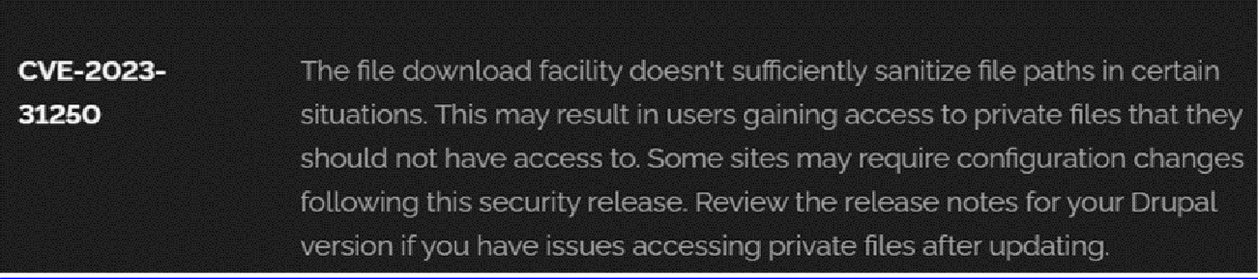

2) Vulnerability Name: Invalid Certificate
CWE-395: Improper Certificate Validation

OWASP Category: A07:2021 – Identification and Authentication Failures

Description: When a certificate is invalid or malicious, it might allow an attacker to spoof a trusted entity by interfering in the communication path between the host and client. The product might connect to a malicious host while believing it is a trusted host, or the product might be deceived into accepting spoofed data that appears to originate from a trusted host.
Business Impact: Improper certificate validation can lead to a range of security threats which includes Man-in-the-middle attacks(Attackers can intercept communication between two parties and read or modify the data exchanged between them),Data breaches:(Attackers can gain unauthorized access to sensitive information or sensitive systems, leading to data breaches),Malware distribution(Attackers can use fake digital certificates to distribute malicious software or infect systems with malware)
Steps to Reproduce: https://www.ssllabs.com/ssltest/analyze?d=www.itsecgames.com

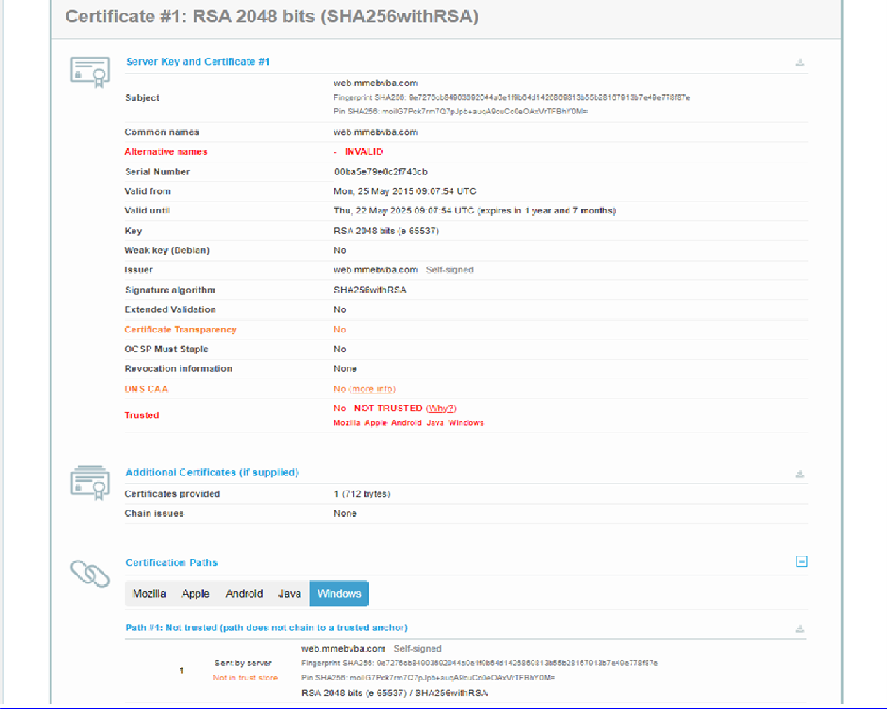

3) Vulnerability Name: Missing X-Frame-Options Header

CWE-1021: Design Improper Restriction of Rendered UI Layers or Frames

OWASP Category: A04:2021-Insecure Design

Description: A web application is expected to place restrictions on whether it is allowed to be rendered within frames, iframes, objects, embed or applet elements. Without the restrictions, users can be tricked into interacting with the application when they were not intending to.
Business Impact: This enables path to the attackers to manipulate or gain unauthorized access to user interface elements, potentially leading to deceptive or malicious user interactions. This can result in data leakage, fraud, user distrust, and reputational damage, undermining the integrity and trustworthiness of the application and causing financial losses.
Vulnerability Path: http://www.itsecgames.com/

- Open the practice website to inspect
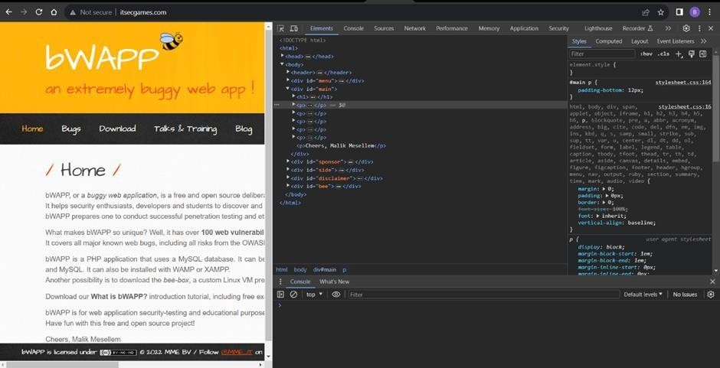

- Go to network and start capturing using F5 or Ctrl+R

- Go to html document and see if x-frame-options present in response headers or not

- If not the absence of this header indicates that the website may not have protection against embedding its content within an iframe on other domains, potentially leaving it vulnerable to clickjacking attacks.

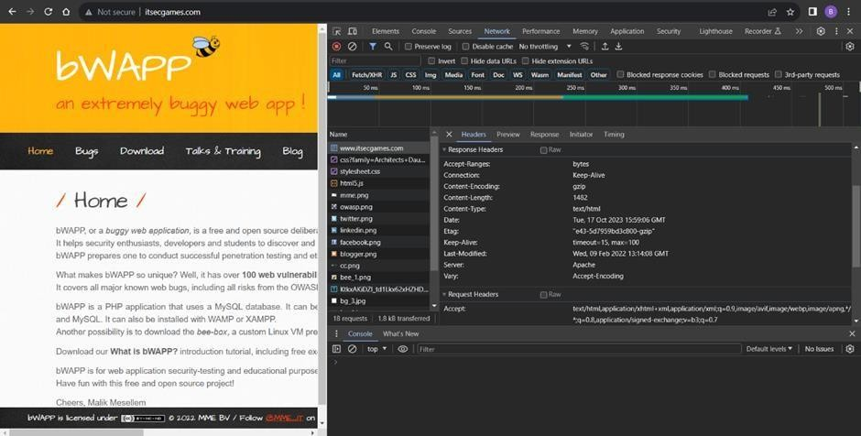

4) Vulnerability Name: X-Content-Type Options Header Missing CWE -918: Server-Side Request Forgery (SSRF)
OWASP Category: A10:2021 – Server-Side Request Forgery (SSRF)

Description: The web server receives a URL or similar request from an upstream component and retrieves the contents of this URL, but it does not sufficiently ensure that the request is being sent to the expected destination.

Business Impact: The header missing impact Data Exposure(Attackers might force the server to render sensitive data as HTML, leading to data exposure),Security Risks(Content type manipulation can increase security risks, potentially leading to breaches, data leaks, and unauthorized access), Brand and Reputation Damage(Successful attacks that exploit SSRF vulnerabilities can harm the organization's reputation and trustworthiness)
Vulnerability Path :
https://securityheaders.com/?q=http%3A%2F%2Fwww.itsecgames.com%2F&followRedirects= on
Steps to Reproduce:
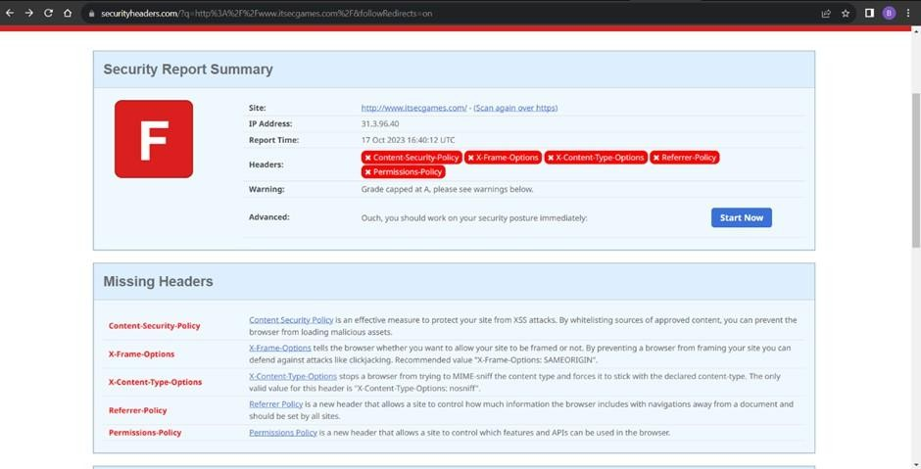

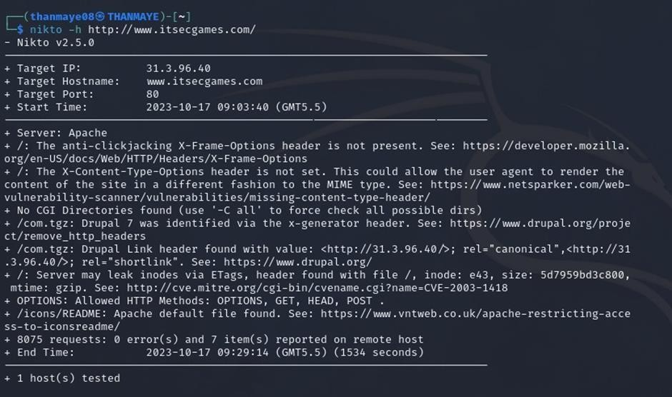

5) Vulnerability Name: Drupal Ajax API shows JSONP not disabled by default

CWE-937,1035: OWASP Top Ten 2013,2017 Category A9 - Using Components with Known
Vulnerabilities
OWASP Category: A06:2021-Vulnerable and Outdated Components

Description: Vulnerable and outdated components refer to using software libraries, modules, or dependencies within a web application that have known security issues or are not updated to the latest secure versions. This can include plugins, frameworks, or APIs that are no longer maintained or have publicly documented vulnerabilities.
Business Impact: The presence of vulnerable and outdated components in a web application poses significant security risks. Attackers can exploit these weaknesses to gain unauthorized access, inject malicious code, steal sensitive data, or disrupt the system's operation. The potential business impacts include compromised user data, damaged reputation, legal consequences, and financial losses due to breach recovery and remediation efforts.
Vulnerability Path: https://www.shodan.io/host/31.3.96.40

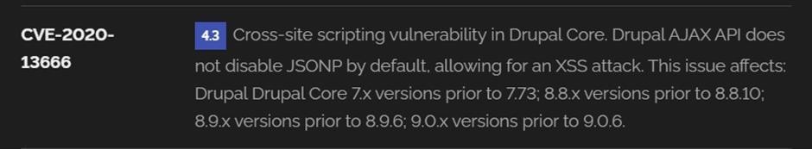

6) Vulnerability Name: Drupal Api Vulnerability
CWE-20: Improper Input Validation
OWASP Category: A03:2021 – Injection

Description: The product receives input or data, but it does not validate or incorrectly validates that the input has the properties that are required to process the data safely and correctly.
Business Impact: The impact of a successful SQL injection attack can be devastating for businesses. It can result in unauthorized access to sensitive information, data theft, financial losses, damage to reputation, and legal consequences. Depending on the nature of the application and data involved, SQL injection can lead to compliance violations, customer trust erosion, and operational disruption.
Vulnerability Path: https://www.shodan.io/host/31.3.96.40

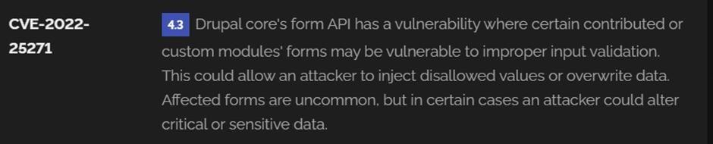

7) Vulnerability Name: Improper API Filtration

CWE-79: Improper Neutralization of Input During Web Page Generation ('Cross-site Scripting')

OWASP Category: A07-2017: Cross-site Scripting (XSS)

Description: The product does not neutralize or incorrectly neutralizes user-controllable input before it is placed in output that is used as a web page that is served to other users.
Business Impact: If exploited, this vulnerability allows attackers to inject malicious scripts into web pages, which can be viewed by other users. The potential business impacts include data theft, unauthorized access, compromised user accounts, damaged reputation, and financial losses. Attackers can use XSS to steal sensitive information, such as user credentials, personal data, or financial details, leading to regulatory compliance violations and legal liabilities. Additionally, defacement or manipulation of website content can erode customer trust and result in lost revenue.
Vulnerability Path: https://www.shodan.io/host/31.3.96.40 Steps to Reproduce:
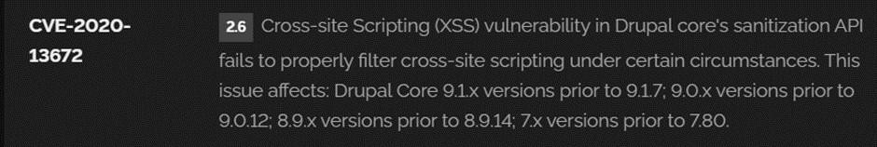

8) Vulnerability Name: Denial of Service

CWE -400: Uncontrolled Resource Consumption

OWASP Category:

Description: The Denial of Service (DoS) attack is focused on making a resource (site, application, server) unavailable for the purpose it was designed. There are many ways to make a service unavailable for legitimate users by manipulating network packets, programming, logical, or resources handling vulnerabilities, among others. If a service receives a very large number of requests, it may cease to be available to legitimate users. In the same way, a service may stop if a programming vulnerability is exploited, or the way the service handles resources it uses.
Sometimes the attacker can inject and execute arbitrary code while performing a DoS attack in order to access critical information or execute commands on the server. Denial-of-service attacks significantly degrade the service quality experienced by legitimate users. These attacks introduce large response delays, excessive losses, and service interruptions, resulting in direct impact on availability.
Business Impact: If successfully exploited, it involves overwhelming a system or application with excessive demands on its resources. This can lead to a range of disruptive consequences. The targeted system may experience significant slowdowns, or even complete unresponsiveness, making it difficult or impossible for legitimate users to access. Critical resources like CPU, memory, and network bandwidth can become depleted, causing further degradation in performance. In severe cases, the exploited vulnerability may lead to system crashes or failures, potentially resulting in data loss. This disruption not only impacts business productivity and financial stability but also risks reputational damage, eroding customer trust and confidence. Additionally, organizations may face regulatory compliance issues if the uncontrolled resource consumption leads to violations of service level agreements or industry standards. Mitigating this vulnerability requires proactive resource management practices and a well-prepared incident response plan to minimize the potential impacts on business operations and customer satisfaction.
Steps to Reproduce: exploit open ports 80 to perform SQL injections, cross-site request forgeries and DDoS attacks.
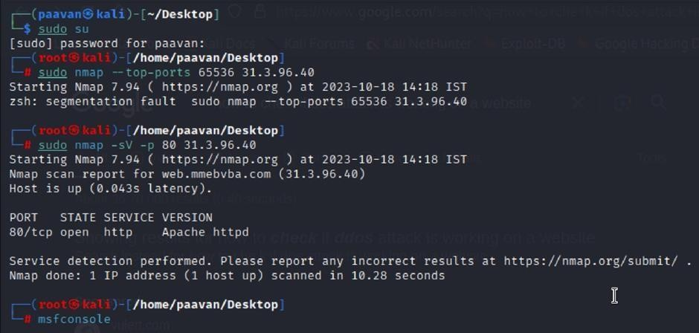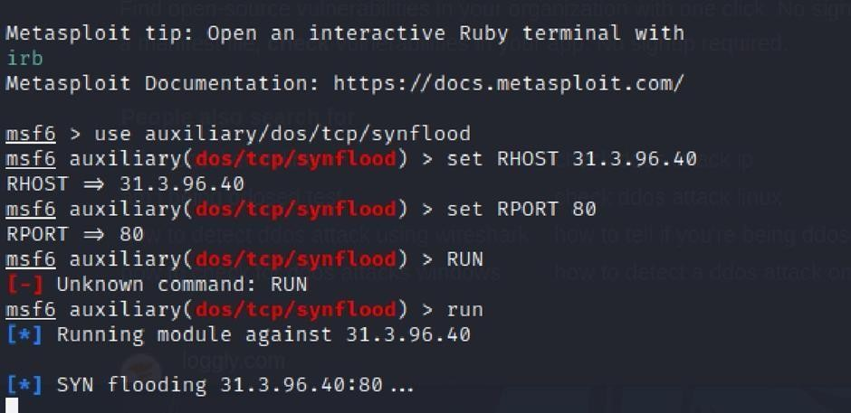

9) Vulnerability Name: TLS Version 1.0 Protocol Detection
CWE-327: Use of a Broken or Risky Cryptographic Algorithm
OWASP Category: A02:2021-Cryptographic Failures
Description: The product uses a broken or risky cryptographic algorithm or protocol.

Business Impact: TLS 1.0 is an outdated and vulnerable encryption protocol, and its use can expose sensitive data to potential security threats. This not only jeopardizes the integrity of customer information and payment details but also tarnishes the company's reputation. The business may face legal consequences, loss of customer trust, and decreased revenue as security- conscious users avoid the site due to its security vulnerabilities. Immediate action is necessary to upgrade to a more secure TLS version to safeguard data, ensure compliance, and maintain customer confidence.
Steps to Reproduce:

- Open a terminal or command prompt

- Type the Command: openssl s_client -connect 31.3.96.40:443 -tls1

- The connection is successfully means the server supports TLS 1.0
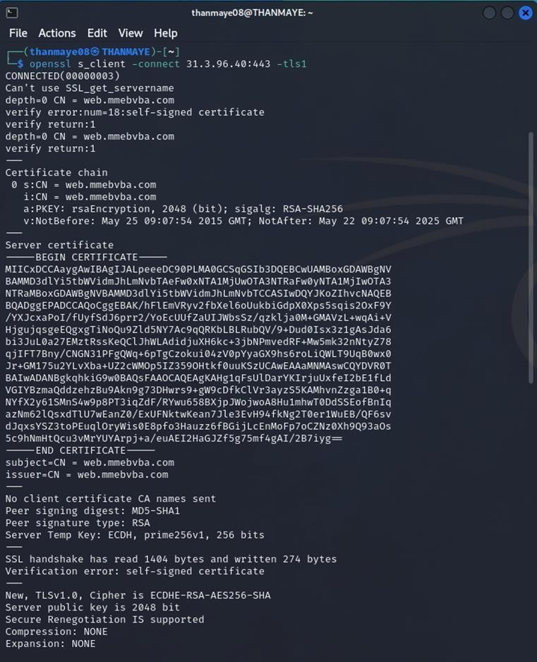
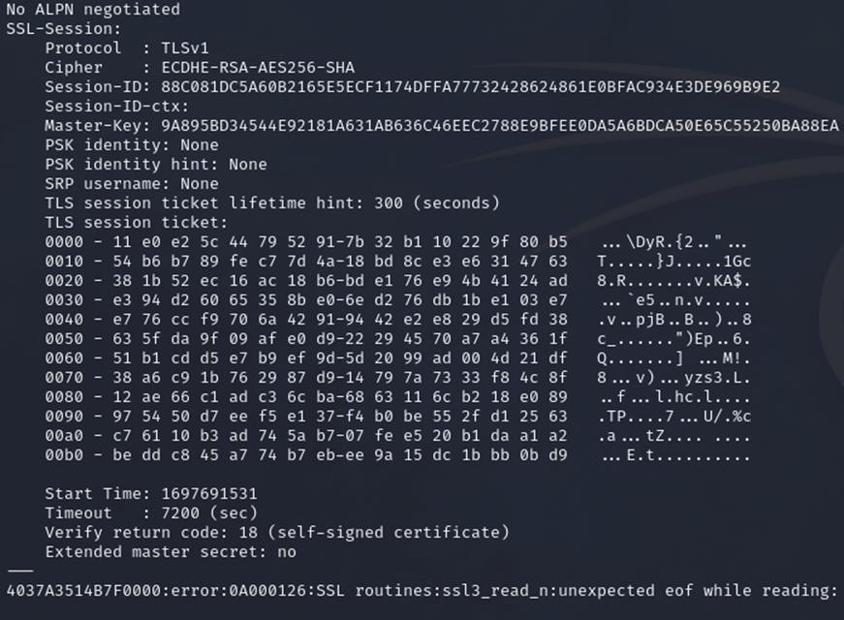

10) Vulnerability Name: web.config File Information Disclosure

CWE-497: Exposure of Sensitive System Information to an Unauthorized Control Sphere

OWASP Category: A3:2017-Sensitive Data Exposure
Description: An information disclosure vulnerability exists in the remote web server due to the disclosure of the web.config file. An unauthenticated, remote attacker can exploit this, via a simple GET request, to disclose potentially sensitive configuration information.
Business Impact: It exposes sensitive configuration details, including database connection strings and encryption keys, to potential attackers. This could lead to unauthorized access, data breaches, and system compromise. The impact includes financial losses, damage to reputation, and legal liabilities as the organization's security and customer trust are compromised.
Steps to Reproduce:

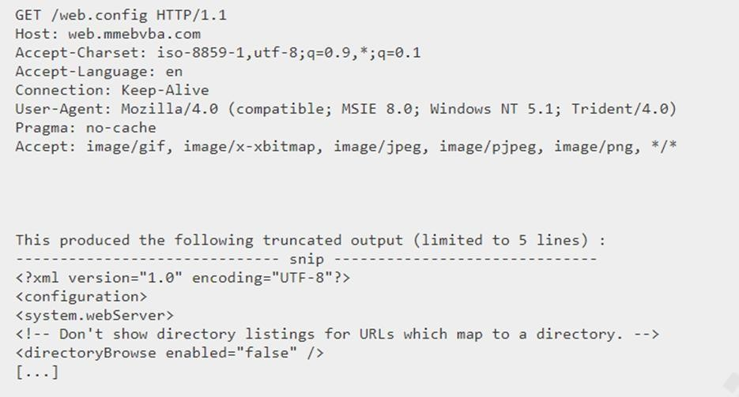

Main Website: vtop.vit.ac.in

1) Vulnerability Name: SL Medium Strength Cipher Suites Supported (SWEET32)
CWE-200: Exposure of Sensitive Information to an Unauthorised Actor
OWASP Category: Broken access control

Description: The remote host supports the use of SSL ciphers that offer medium strength encryption. Nessus regards medium strength as any encryption that uses key lengths at least 64 bits and less than 112 bits, or else that uses the 3DES encryption suite.
Note that it is considerably easier to circumvent medium strength encryption if the attacker is on the same physical network.
Business Impact: The vulnerability known as SWEET32 (Short for Sweet 32 Birthday Attack) relates to the continued use of legacy cryptographic cipher suites with 64-bit block sizes in TLS and SSL protocols. These suites are susceptible to birthday attacks, which exploit the probability of two blocks colliding after a certain number of transactions. If an organisation's systems are vulnerable to SWEET32, it means they're potentially at risk of having encrypted communications intercepted or manipulated. This could lead to unauthorised access, data theft, or even the injection of malicious code. As a result, businesses face a significant risk to the confidentiality and integrity of their sensitive information. Remediation involves updating systems to support more secure cipher suites with larger block sizes, which would effectively mitigate this vulnerability and enhance the overall security posture. Failure to address SWEET32 could leave an organisation exposed to increasingly sophisticated attacks and legal consequences due to potential data breaches.
Vulnerability Path : The Sweet32 vulnerability when detected with a vulnerability scanner will report it as a CVSS 7.5.
Steps to Reproduce:
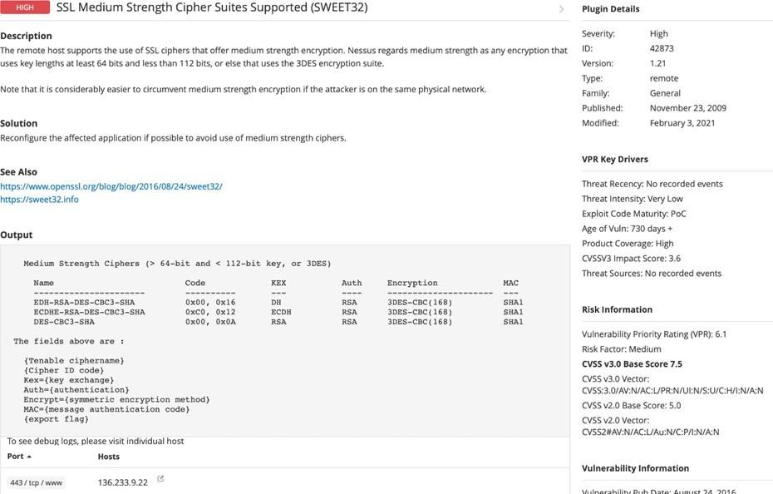

2) Vulnerability Name: Cookie SERVERID created without secue flag
CWE-79: Improper Neutralization of Input During Web Page Generation
OWASP Category: A07-2017: Cross-site Scripting
Description: The vulnerability allows an attacker to inject malicious code into a WordPress website, which can then be executed by visitors to the website.
To exploit this vulnerability, an attacker would simply need to trick a user into clicking on a malicious link or opening a malicious attachment. Once the user clicks on the link or opens the attachment, the attacker's code would be executed, giving the attacker control over the user's account and potentially the entire WordPress website.
Business Impact: The business consequences of XSS can be severe, ranging from reputational damage due to compromised customer trust, to legal repercussions in cases of data breaches. Moreover, it can lead to financial losses through fraud or the cost of remediation efforts. Beyond the immediate impacts, long-term harm may occur if customers abandon the platform due to security concerns. To mitigate CWE-79, businesses must implement rigorous input validation and output encoding practices, as well as stay vigilant for emerging threats in web application security. Failure to address XSS vulnerabilities could result in significant harm to both the business's reputation and its bottom line.

Vulnerability Path: https://securityheaders.com/

q=http%3A%2F%2Fvtop.vit.ac.in%2F&followRedirects=on

Steps to Reproduce:

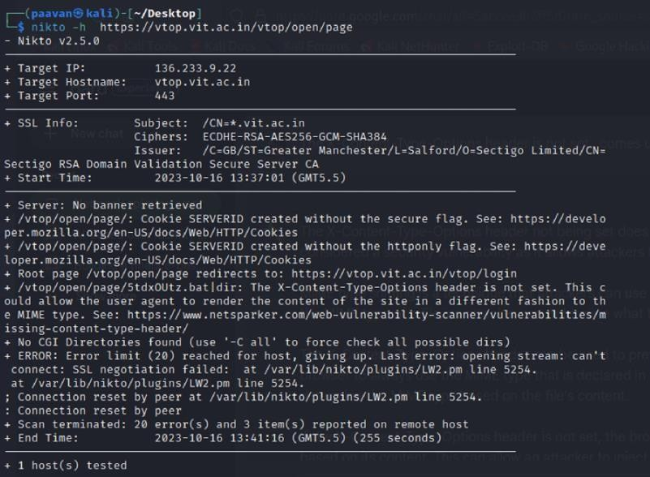

3) Vulnerability Name: X-Content-Type Options Header Missing
CWE-918: Server-Side Request Forgery (SSRF)
OWASP Category: A10:2021 – Server-Side Request Forgery (SSRF)

Description: The absence of the "X-Content-Type-Options" header poses a notable security risk for web applications. This header is a crucial security feature that instructs the browser to interpret files with a MIME type as declared in the Content-Type header, rather than trying to guess the type. When this header is missing, the browser may attempt to infer the content type, leaving room for potential misinterpretation and security vulnerabilities like MIME-sniffing attacks. This could enable attackers to disguise malicious content, such as scripts or executable files, as benign content, leading to Cross-Site Scripting (XSS) or other types of attacks. Implementing the "X-Content-Type-Options" header with the value "nosniff" is a fundamental security measure that helps prevent these risks. It ensures that browsers strictly adhere to the declared content type, enhancing the overall security posture of the web application and safeguarding against potential exploitation stemming from content misinterpretation.
Business Impact: The header missing impact Data Exposure(Attackers might force the server to render sensitive data as HTML, leading to data exposure),Security Risks(Content type manipulation can increase security risks, potentially leading to breaches, data leaks, and unauthorized access), Brand and Reputation Damage(Successful attacks that exploit SSRF vulnerabilities can harm the organization's reputation and trustworthiness)
Vulnerability Path :
https://securityheaders.com/?q=http%3A%2F%2Fvtop.vit.ac.in%2F&followRedirects=on

Steps to Reproduce:
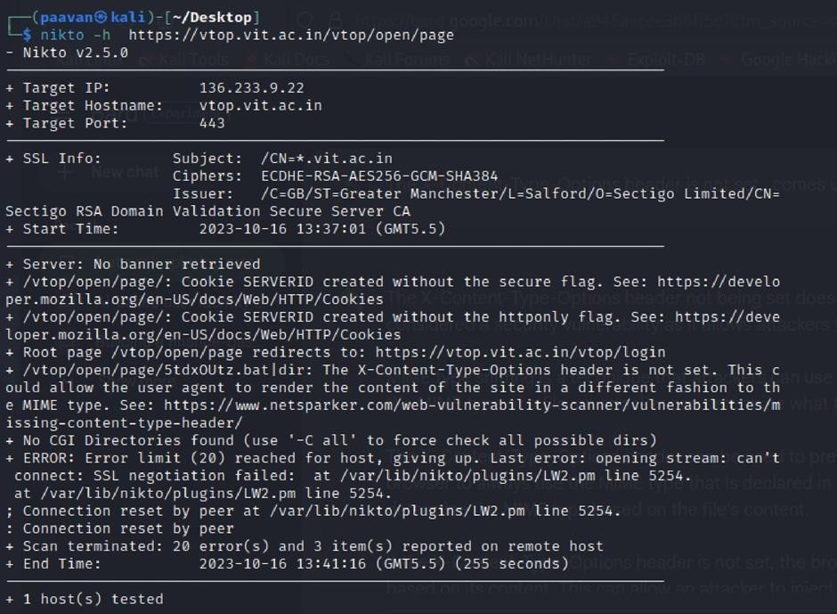

4) Vulnerability Name: Denial of Service

CWE - 400: Uncontrolled Resource Consumption

Description: The Denial of Service (DoS) attack is focused on making a resource (site, application, server) unavailable for the purpose it was designed. There are many ways to make a service unavailable for legitimate users by manipulating network packets, programming, logical, or resources handling vulnerabilities, among others. If a service receives a very large number of requests, it may cease to be available to legitimate users. In the same way, a service may stop if a programming vulnerability is exploited, or the way the service handles resources it uses.
Sometimes the attacker can inject and execute arbitrary code while performing a DoS attack in order to access critical information or execute commands on the server. Denial-of-service attacks significantly degrade the service quality experienced by legitimate users. These attacks introduce large response delays, excessive losses, and service interruptions, resulting in direct impact on availability.
Business Impact: If successfully exploited, it involves overwhelming a system or application with excessive demands on its resources. This can lead to a range of disruptive consequences. The targeted system may experience significant slowdowns, or even complete unresponsiveness, making it difficult or impossible for legitimate users to access. Critical resources like CPU, memory, and network bandwidth can become depleted, causing further degradation in performance. In severe cases, the exploited vulnerability may lead to system crashes or failures, potentially resulting in data loss. This disruption not only impacts business productivity and financial stability but also risks reputational damage, eroding customer trust and confidence. Additionally, organizations may face regulatory compliance issues if the uncontrolled resource consumption leads to violations of service level agreements or industry standards. Mitigating this vulnerability requires proactive resource management practices and a well-prepared incident response plan to minimize the potential impacts on business operations and customer satisfaction.
Steps to Reproduce: exploit open ports 443 to perform SQL injections, cross-site request forgeries and DDoS attacks.
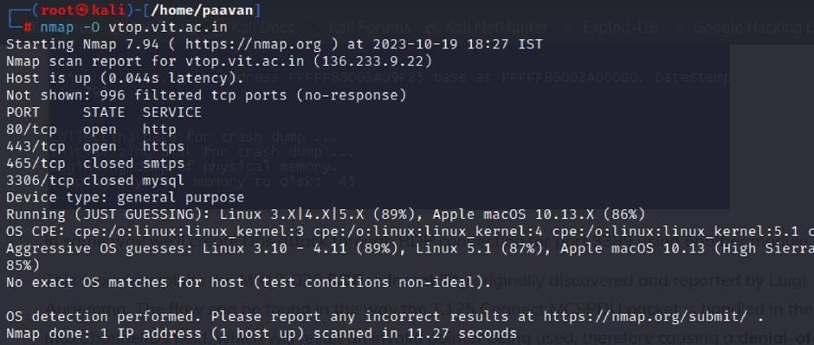

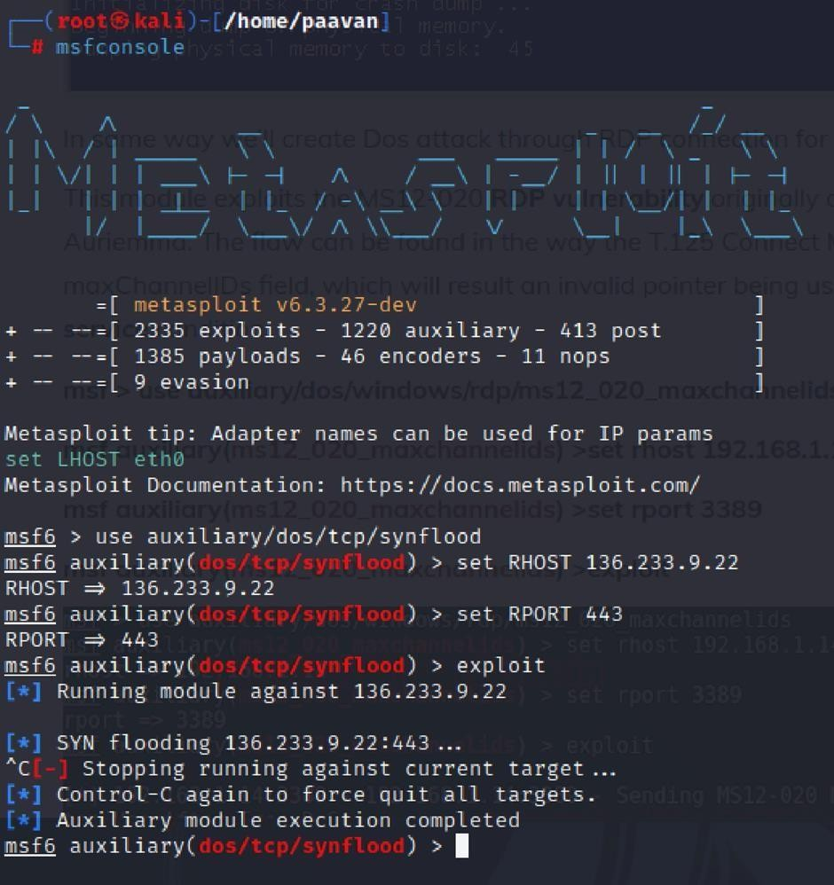

5) Vulnerability Name: OS Identification

CWE-200: Exposure of Sensitive Information to an Unauthorised Actor

OWASP Category: A02:2021-Cryptographic Failures

Description: Using a combination of remote probes (e.g., TCP/IP, SMB, HTTP, NTP, SNMP, etc.), it is possible to guess the name of the remote operating system in use. It is also possible sometimes to guess the version of the operating system.
Business Impact: If sensitive information is improperly handled or inadequately protected, it can lead to financial losses, regulatory penalties, and damage to reputation. Customers may lose trust in the organization's ability to safeguard their data, potentially resulting in a loss of business and market share. Legal consequences and compliance issues may arise, leading to additional costs. Moreover, intellectual property theft or exposure can compromise a company's competitive edge. Remediation efforts, including implementing stronger security measures and compensating affected parties, can also entail substantial expenses. Overall, CWE-200 highlights the critical importance of robust data protection measures to safeguard an organization's financial health, reputation, and long-term viability.
Steps to Reproduce: use nmap -O TARGET to enable os detection
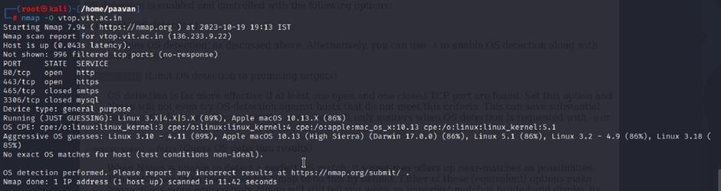

This is stage 1 in the context of web application testing and security we take help from
OWASP top 10 to understand them. The OWASP Top 10 is a widely recognized list of the most critical web application security risks. Understanding these risks is essential for ensuring the security of web applications.

Stage 2
Overview :-

Nessus is a vulnerability scanner developed by Tenable, Inc. It is a remote scanner, meaning that it does not need to be installed on the target host to scan it. Nessus works by sending a variety of probes to the target host in order to identify vulnerabilities. These probes can include network traffic, operating system commands, and application requests.

Nessus uses a plugin-based architecture. Plugins are small pieces of code that are designed to identify specific vulnerabilities. There are over 1200 plugins available for Nessus, covering a wide range of vulnerabilities in operating systems, applications, and network devices.

When Nessus scans a host, it first uses a discovery plugin to identify the operating system and services running on the host. Once the host has been discovered, Nessus runs a series of plugins to test for vulnerabilities. For each vulnerability that Nessus finds, it provides a detailed report that includes the severity of the vulnerability, the steps to reproduce the vulnerability, and the steps to remediate the vulnerability.
Nessus can be used to scan a variety of targets, including single hosts, networks, and web applications. It can also be used to scan specific ports and services. Nessus can be configured to run scans on a schedule or manually.

Here is a step-by-step explanation of how Nessus works:

- Nessus connects to the target host using a variety of protocols, including TCP, UDP, and ICMP.
- Nessus sends a series of probes to the target host in order to identify its operating system and services.
- Nessus runs a series of plugins to test for vulnerabilities.
- Nessus generates a report that includes the severity of each vulnerability, the steps to reproduce the vulnerability, and the steps to remediate the vulnerability.

Nessus is a valuable tool for security professionals who need to identify and remediate vulnerabilities in their networks. It is easy to use and provides comprehensive reports that can be used to prioritise remediation efforts.

Here are some of the benefits of using Nessus:

- Comprehensive vulnerability coverage: Nessus has over 1200 plugins available, covering a wide range of vulnerabilities in operating systems, applications, and network devices. ● Easy to use: Nessus has a user-friendly interface that makes it easy to configure and run scans.
- Comprehensive reporting: Nessus provides detailed reports that include the severity of each vulnerability,the steps to reproduce the vulnerability, and the steps to remediate the vulnerability.
- Scalability: Nessus can be used to scan a variety of targets, including single hosts, networks, and web applications.
- Flexibility: Nessus can be configured to run scans on a schedule or manually.

Nessus is a powerful tool that can be used to improve the security of any network. It is a valuable asset for any security professional.

Target website :- http://testfire.net/
Target ip address:- 65.61.137.117

List of vulnerability:-
s.no | Vulnerability name | Severity | plugins
1 | TLS Version 1.0 Protocol  Detection | MEDIUM | 104743
2 | TLS Version 1.1 Protocol  Deprecated | MEDIUM | 157288
3 | SSL/TLS Diffie-Hellman Modulus  <= 1024 Bits (Logjam) | LOW | 83875
4 | ICMP Timestamp Request Remote  Date Disclosure | INFO | 10114
5 | Additional DNS Hostnames | INFO | 46180
6 | Apache Tomcat Detection | INFO | 39446
7 | Common Platform Enumeration  (CPE) | INFO | 45590
8 | Device Type | INFO | 54615
9 | HSTS Missing From HTTPS Server | INFO | 84502
10 | HTTP Server Type and Version | INFO | 10107

REPORT: -

1) Vulnerability Name: - 104743 - TLS Version 1.0 Protocol Detection
Severity: - MEDIUM
Plugin: - 104743

Port: - 443
Description: - The remote service accepts connections encrypted using TLS 1.0. TLS 1.0 has a number of cryptographic design flaws. Modern implementations of TLS 1.0 mitigate these problems, but newer versions of TLS like 1.2 and 1.3 are designed against these flaws and should be used whenever possible.
As of March 31, 2020, Endpoints that aren’t enabled for TLS 1.2 and higher will no longer function properly with major web browsers and major vendors.
PCI DSS v3.2 requires that TLS 1.0 be disabled entirely by June 30, 2018, except for POS POI terminals (and the SSL/TLS termination points to which they connect) that can be verified as not being susceptible to any known exploits.
Solution: - Enable support for TLS 1.2 and 1.3, and disable support for TLS 1.0.
Business Impact: -Continued use of TLS 1.0's encryption, known for its inherent cryptographic flaws, exposes the organization to heightened security risks, increasing the likelihood of data breaches and cyberattacks. This vulnerability jeopardizes compliance with industry standards, specifically PCI DSS v3.2, which mandates the complete cessation of TLS 1.0 use. Non- compliance risks regulatory penalties and erodes customer trust. Moreover, endpoints that lack support for TLS 1.2 and higher will experience impaired functionality with major web browsers and vendors, potentially leading to lost business opportunities and damage to the organization's reputation. Addressing this vulnerability is imperative to mitigate these multifaceted risks and maintain a secure and trustworthy online presence.

2) Vulnerability Name: - 157288 - TLS Version 1.1 Protocol Deprecated
Severity: - MEDIUM
Plugin: - 157288

Port: - 443
Description: - The remote service accepts connections encrypted using TLS 1.1. TLS 1.1 lacks support for current and recommended cipher suites. Ciphers that support encryption before MAC computation, and authenticated encryption modes such as GCM cannot be used with TLS 1.1 As of March 31, 2020, Endpoints that are not enabled for TLS 1.2 and higher will no longer function properly with major web browsers and major vendors.
Solution: - Enable support for TLS 1.2 and/or 1.3, and disable support for TLS 1.1.
Business Impact: -The continued use of TLS 1.1 with its lack of support for modern cipher suites and advanced encryption methods jeopardizes the organization's security posture, increasing vulnerability to cyber threats and potential data breaches. Additionally, endpoints not upgraded to support TLS 1.2 and higher will encounter compatibility issues with major web browsers and vendors, impacting user experience and potentially leading to missed business opportunities. Swift remediation of this vulnerability is essential to mitigate security risks and ensure seamless interactions with web browsers and vendors, preserving the organization's reputation and operational efficiency.

3) Vulnerability Name: - 83875 - SSL/TLS Diffie-Hellman Modulus <= 1024 Bits (Logjam)
Severity: - LOW
Plugin: - 83875

Port: - 443
Description: - The remote host allows SSL/TLS connections with one or more Diffie-Hellman moduli less than or equal to 1024 bits. Through cryptanalysis, a third party may be able to find the shared secret in a short amount of time (depending on modulus size and attacker resources). This may allow an attacker to recover the plaintext or potentially violate the integrity of connections.
Solution: - Reconfigure the service to use a unique Diffie-Hellman moduli of 2048 bits or greater.
Business Impact: - Allowing SSL/TLS connections with weak Diffie-Hellman moduli raises security concerns. An attacker with sufficient resources and computing power could compromise the shared secret relatively quickly, potentially leading to the decryption of sensitive data or the violation of connection integrity. While the severity is low, the risk of data breaches and integrity compromise should not be underestimated, and it is essential to address this vulnerability to maintain data security and user trust.
4) Vulnerability Name: - 10114 - ICMP Timestamp Request Remote Date Disclosure
Severity: - INFO
Plugin: - 10114

Port: - 0
Description: - The remote host answers to an ICMP timestamp request. This allows an attacker to know the date that is set on the targeted machine, which may assist an unauthenticated, remote attacker in defeating time-based authentication protocols.
Timestamps returned from machines running Windows Vista / 7 / 2008 / 2008 R2 are deliberately incorrect, but usually within 1000 seconds of the actual system time.
Solution: - Filter out the ICMP timestamp requests (13), and the outgoing ICMP timestamp replies (14).
Business Impact: -This does not pose an immediate threat to business operations or data security. This vulnerability allows external parties to request the system's date and time information remotely. While it does not present a significant risk, it could potentially be used by attackers for reconnaissance purposes. Therefore, it is advisable to address this vulnerability as part of a broader security posture to reduce the risk of unauthorized data gathering and protect against potential future threats.

5) Vulnerability Name: - 46180 - Additional DNS Hostnames
Severity: - INFO
Plugin: - 46180

Port: - 0
Description: - Hostnames different from the current hostname have been collected by miscellaneous plugins. Nessus has generated a list of hostnames that point to the remote host.
Note that these are only the alternate hostnames for hosts discovered on a web server.
Different web servers may be hosted on name-based virtual hosts.
Solution: - If you want to test them, re-scan using the special vhost syntax, such as :
www.example.com [192.0.32.10]
Business Impact: -This does not pose an immediate threat to business operations or data security. It indicates the discovery of hostnames that are associated with the remote host, particularly in cases of web servers utilizing name-based virtual hosts. While not a security risk on its own, it could be useful for understanding the server's configuration and infrastructure. Organizations should consider this information as part of their network documentation but do not need to take immediate action to mitigate it as a security threat.

6) Vulnerability Name: - 39446 - Apache Tomcat Detection
Severity: - INFO
Plugin: - 39446

Port: - 80
Description: -Nessus was able to detect a remote Apache Tomcat web server.
Solution: - n/a
Business Impact: -Is an informational finding that identifies the presence of a remote Apache Tomcat web server. While this information itself does not indicate a security threat or impact on business operations, it can be useful for network administrators and security professionals to be aware of the technologies in use on their network. Understanding the presence of an Apache Tomcat server can be valuable for maintaining and securing web applications, but it does not require immediate action to mitigate a security risk.

7) Vulnerability Name: - 45590 - Common Platform Enumeration (CPE)
Severity: - INFO
Plugin: - 45590
Port: - 0
Description: - By using information obtained from a Nessus scan, this plugin reports CPE
(Common Platform Enumeration) matches for various hardware and software products found on a host.
Note that if an official CPE is not available for the product, this plugin computes the best possible CPE based on the information available from the scan.
Solution: - n/a
Business Impact: - This provides insights into hardware and software products identified on a host through a Nessus scan. It reports CPE matches, which are standardized identifiers for these products. This information is valuable for asset management and inventory purposes. While it doesn't signify a security threat, it aids administrators in understanding the components within their network, contributing to effective resource management and facilitating future system maintenance.

8) Vulnerability Name: - Device Type
Severity: - INFO
Plugin: - 54615

Port: - 0
Description: - Based on the remote operating system, it is possible to determine what the remote system type is (eg: a printer, router, general-purpose computer, etc).
Solution: -
Business Impact: - It allows for the identification of the remote system type, such as a printer, router, or general-purpose computer, based on the remote operating system. While this doesn't pose a direct security threat, it offers valuable insights for network administrators to better understand and classify the devices in their network. This information aids in network management, optimization, and ensures that the right security measures are in place for each device type.

9) Vulnerability Name: - 84502 - HSTS Missing From HTTPS Server
Severity: - INFO
Plugin: - 84502

Port: - 443
Description: -The remote HTTPS server is not enforcing HTTP Strict Transport Security (HSTS). HSTS is an optional response header that can be configured on the server to instruct the browser to only communicate via HTTPS. The lack of HSTS allows downgrade attacks, SSL- stripping man-in-the-middle attacks, and weakens cookie-hijacking protections.
Solution: - Configure the remote web server to use HSTS.
Business Impact: -Indicates that the remote HTTPS server does not enforce HTTP Strict Transport Security (HSTS). HSTS is a crucial security feature that, when configured on the server, instructs web browsers to communicate exclusively via HTTPS, enhancing security. The absence of HSTS potentially exposes the server to downgrade attacks, SSL-stripping man-in-the- middle attacks, and weakens protections against cookie hijacking, posing risks to data confidentiality and user security. Enabling HSTS is essential to ensure a higher level of protection for data transmitted between clients and the server.

10) Vulnerability Name: - 10107 - HTTP Server Type and Version
Severity: - INFO
Plugin: - 10107

Port: - 443
Description: - This plugin attempts to determine the type and the version of the remote web server.
Solution: - N/A
Business Impact: -This relates to the identification of the remote web server's type and version. While this issue doesn't pose an immediate security threat, it can provide valuable information to potential attackers about the server's software stack. Knowledge of the server type and version may aid attackers in exploiting known vulnerabilities specific to that software, making it important to restrict such information from being easily accessible to enhance the server's overall security posture.

Stage-3

Report: -

Title: - Implementing Zero Trust Network Access (ZTNA) with Zscaler: Securing
User-to-Application Connectivity

• Zero Trust Network Access (ZTNA)
Zero Trust Network Access (ZTNA) is an IT security framework that provides secure remote access to an organization's internal applications and data based on clearly defined access control policies. Unlike traditional Virtual Private Networks (VPNs), which grant users broad access to the entire network, ZTNA operates on a "never trust, always verify" principle. It grants users access only to the specific applications they need, and only after their identity and device have been verified.
ZTNA is a critical component of modern security architecture. It helps organizations move away from the concept of a trusted internal network and an untrusted external network (the "castleand-moat" model). By hiding the internal network from the internet and establishing one-to-one, encrypted connections between users and applications, ZTNA drastically reduces the attack surface and stops common threats like lateral movement by attackers.

• The ZTNA Access Cycle
The ZTNA cycle is a continuous process of verifying identity, establishing secure connections, and enforcing policy for every access request. It typically consists of the following steps:
- User Request: A user, from any location (office, home, coffee shop), requests access to a specific internal application (e.g., an HR portal, a finance server, or an internal code repository).

- Identity and Device Verification: Before any connection is established, the ZTNA solution verifies who the user is (via multi-factor authentication, or MFA) and checks the security posture of their device. This includes ensuring the device has up-to-date antivirus, a healthy firewall, and is not compromised.
- Policy Enforcement: The ZTNA solution checks the access policy. Does this specific user, with this specific device, have permission to access the requested application at this specific time?
- Establish Secure Connection: If the policy allows access, the ZTNA solution creates a highly secure, encrypted micro-tunnel between the user's device and the target application.
Crucially, the user never gains access to the underlying network, only to the application itself.
- Continuous Monitoring: The ZTNA solution continues to monitor the connection for anomalies. If the user's behavior becomes suspicious or their device posture changes, the connection can be terminated in real-time.
- Logging and Analytics: All access attempts, successful and failed, are logged and analyzed.
This data is used for auditing, threat hunting, and refining access policies.

• Zscaler (Zscaler Internet Access / Zscaler Private Access)
Zscaler is a cloud-native security platform that delivers its services entirely from the cloud, eliminating the need for on-premises hardware like VPN concentrators. For ZTNA, Zscaler offers Zscaler Private Access (ZPA) . ZPA is a service that provides seamless, identity-based access to private applications without ever placing users on the network.
Zscaler ZPA operates on a simple principle: the application is "inside" the Zscaler cloud, and the user connects to it there. It collects data from a variety of sources, including:
- Identity Providers (IdP): Such as Azure AD, Okra, or Ping Identity, to verify user identities.
- Device Posture Partners: Such as CrowdStrike, Tanium, or Microsoft Defender for Endpoint, to check the health of the endpoint.
- Business Applications: The internal web apps, file servers, and legacy applications hosted in data centers or public clouds (e.g., AWS, Azure).
- Zscaler App Connectors: Lightweight software components deployed in the data center or cloud that initiate outbound connections to the Zscaler cloud, making internal servers invisible to the internet.

Zscaler then enforces policies based on this data, including:
- Identity-Based Access: Policies are built around user and group identities, not IP addresses.
- Application Segmentation: Users are granted access to specific applications, not entire subnets.
- Least Privilege Access: Ensures users have the minimum level of access required to perform their jobs.

• The Zscaler ZTNA Cycle
The Zscaler ZTNA cycle is the practical application of the ZTNA principles using the Zscaler cloud. The cycle typically consists of the following steps:
- User Login and Authentication: A user attempts to access an internal application. They are redirected to their organization's Identity Provider (IdP) for authentication and MFA.
- Device Posture Check (Integration): Zscaler checks with integrated endpoint protection tools to ensure the device is compliant with security policies.
- Policy Lookup and Decision: The Zscaler cloud evaluates the request against the defined access policies. It verifies that the user, device, and context (time, location) are authorized for that specific application.
- Establishing the Micro-tunnel: Once authorized, the Zscaler cloud instructs the user's Zscaler Client Connector and the appropriate Zscaler App Connector in the data center to establish an encrypted connection. The user is now connected to the application.
- Traffic Inspection (Optional): For sanctioned applications, Zscaler can optionally inspect the traffic for data loss prevention (DLP) or to detect malware.
- Logging and Analytics: All activity is logged in the Zscaler cloud portal for reporting, threat hunting, and compliance.

• MISP (Malware Information Sharing Platform) Integration
While Zscaler is a primary access control tool, it can be enhanced by integrating with threat intelligence platforms like MISP.
- Threat Intelligence Feed: MISP can aggregate and share threat intelligence about malicious domains, IPs, and URLs. This list of indicators of compromise (IOCs) can be fed into Zscaler's cloud.
- Proactive Blocking: If a user, even one authorized by ZPA, attempts to access a known malicious site that has been flagged by the MISP feed, Zscaler Internet Access (ZIA) can block the request, preventing a potential infection.
- Enhanced Visibility: Security teams can use MISP to cross-reference Zscaler logs. If a user's behavior is anomalous, the team can check MISP to see if the destination IP or domain is associated with a known threat actor or campaign.
  - Your College Network Information
This infrastructure presents a large attack surface, especially with the need for remote learning and administrative access. The network includes:

  - Core routers and switches
  - Distribution routers and switches
  - Wireless access points
  - Firewalls and Intrusion Detection Systems (IDS)
  - Internal Application Servers: Hosting the student information system, library resources, research data repositories, and administrative portals.
  - Legacy VPN Concentrator: Currently providing broad network-level access for faculty and staff working remotely.
The need for ZTNA arises from the limitations of the current VPN model:
  - Over-permissioned Access: Once on the VPN, a faculty member's compromised laptop could potentially scan and attack the entire internal network (lateral movement).
  - Hidden Applications: Some research applications need to be accessed by external collaborators without granting them full network access.
  - User Experience: The legacy VPN can be slow and cumbersome, often requiring users to route all their internet traffic through the university.
  - How you think you deploy ZTNA using Zscaler in your college
To deploy Zscaler ZTNA (ZPA) in your college, you would start by identifying the specific applications that need to be secured and the user groups that need access to them. This is a shift from securing the network to securing access to applications.
The plan would need to include the following:
- Application Discovery: Catalog all internal applications (e.g., ERP, library system, research servers, file shares) and identify which ones are currently exposed via the VPN.
- User Segmentation: Define user groups (e.g., Students, Faculty - Research, Faculty - Admin, IT Staff, External Collaborators) and the specific applications each group needs.
- Deploying Zscaler App Connectors: Install lightweight App Connector VMs in the university's data center. These connectors will establish outbound connections to the Zscaler cloud, making the application servers invisible to the public internet.
- Integrating Identity Provider: Connect Zscaler to the university's existing Identity Provider (e.g., Microsoft Azure AD) to leverage current usernames, passwords, and MFA policies.
- Configuring Access Policies: Create granular policies in the Zscaler admin portal. For example: "The 'Faculty' group can access the 'ERP Application' from any device that has antivirus enabled, after MFA."

- Deploying Zscaler Client Connector: Students, faculty, and staff will install the Zscaler Client Connector on their laptops and mobile devices. This small client intelligently routes traffic for private applications through ZPA and public traffic through ZIA.
• Threat Intelligence
In the context of Zscaler and ZTNA, threat intelligence is used to understand who is trying to access what, and from where. It helps move beyond simple identity checks to a more contextual understanding of risk. Sources include:
- Zscaler Cloud Logs: Internal logs provide real-time data on who is accessing which applications, from which locations, and on what devices.
- External Threat Feeds (MISP): Information about new malware campaigns, phishing kits, or command-and-control servers being used by attackers.
- Identity Provider Logs: Anomalies in login attempts, such as a user logging in from two geographically impossible locations in a short time, can signal a compromised account.
This intelligence is used for:
- Adaptive Access Control: If threat intelligence suggests a user's location is high-risk, Zscaler can step-up authentication requirements or block access entirely.
- Hunting for Compromised Accounts: Analysts can use Zscaler logs to see if a user is suddenly accessing applications they never have before, which could be a sign of credential theft.
- Blocking Malicious Communication: Threat intelligence feeds can be used by Zscaler Internet Access (ZIA) to block outbound connections to known malicious sites, even if they originate from a user inside the university.
• Incident Response (Adapted for ZTNA)
Incident response in a ZTNA model is faster and more targeted because the environment is inherently more controlled.
- Detection: The SOC team detects an anomaly. For example, a faculty account is downloading an unusually high volume of data from a research server at 3 AM. Zscaler logs provide the exact details: the user, the device, the application, and the amount of data transferred.
- Containment: The SOC team can instantly isolate the user. In the Zscaler portal, they can simply deactivate that user's access or block their specific device. Because there is no networklevel access, this action immediately severs all connections to every application, preventing lateral movement.
- Eradication: The compromised device is taken offline for malware scanning and cleaning by the IT helpdesk.
- Recovery: Once the device is clean and the user's password is reset, the Zscaler policy is reenabled, granting the user access again.
- Post-incident review: The security team analyzes the logs to understand how the account was compromised (e.g., a phishing email) and updates Zscaler policies, perhaps by adding a block for similar malicious domains or tightening access rules for that specific research application.
Benefits of this incident response approach:
- Near-Instant Containment: Actions take seconds in a cloud dashboard, not minutes or hours configuring firewall rules.
- No Lateral Movement: The attacker is contained to the single compromised application, protecting the rest of the university's network.
- Granular Forensics: Zscaler provides a detailed audit trail of every connection, making investigations faster and more accurate.
- Compliance: This model helps demonstrate compliance with data protection regulations by proving that access to sensitive student or research data is tightly controlled and audited.
• Understanding about the tool (Zscaler ZPA)
Zscaler Private Access (ZPA) is a cloud service that embodies the ZTNA principle of "connect a user to an app, not the network." Here are the key things to understand:
- It is "Application-Centric," Not "Network-Centric": You define policies based on applications (e.g., "SAP Server 01"), not network constructs like IP subnets. This aligns security with how businesses actually operate.
- It Hides the Network: ZPA uses App Connectors inside your data center that only make outbound connections to the Zscaler cloud. Your internal servers never need to open inbound firewall ports, making them invisible to port scanners and attackers on the internet.
- It uses a "Dark Cloud" Approach: To an external scanner, the organization's applications simply don't exist. They only become visible to authorized users after a multi-step verification process.
- It Provides a Superior User Experience: Users don't have to mess with clunky VPN clients. The Zscaler Client Connector works silently in the background. For web apps, access can even be agentless, requiring only a modern browser.
- It is Inherently Scalable: Because it's a cloud service, ZPA scales instantly to handle thousands of concurrent users, unlike a legacy VPN appliance that needs to be manually upgraded.

Conclusion: -

In conclusion, exploring the realm of AI for web security using IBM QRadar has been an insightful journey through various stages.

In Stage 1, understanding web application testing unveiled the critical importance of assessing vulnerabilities and ensuring the security of web-based systems. This foundational knowledge served as a cornerstone for comprehending the subsequent stages.

Stage 2 delved into the intricacies of Nessus reports, emphasising the significance of detailed vulnerability assessments. Analysing these reports provided valuable insights into potential threats, enabling informed decision-making for robust security measures.

Stage 3 introduced the pivotal concept of Zero Trust Network Access (ZTNA) and its implementation using Zscaler Private Access (ZPA). It demonstrated a paradigm shift from traditional VPN-based network access to secure, identity-based user-to-application connectivity. The solution showcased the power of hiding internal applications from the internet, enforcing granular access policies, and eliminating lateral movement. This underscores the need for modern, proactive cybersecurity strategies in an era of remote work and cloud adoption.

Considering the future scope, Stage 1 illuminated the evolving landscape of web application testing. With advancements in AI, there is a promising avenue for more sophisticated testing methodologies, ensuring even higher levels of security for web applications.

Stage 2 highlighted the future trajectory of the testing process, indicating a shift towards more automation and integration of AI-driven tools. This evolution promises quicker, more accurate vulnerability assessments, enhancing overall cybersecurity postures.

Stage 3 illuminated the future potential of Zero Trust Network Access (ZTNA) and Zscaler technologies. With AI integration and machine learning, these systems are poised to become more intelligent and adaptive, enabling real-time risk assessment based on user behavior and device posture. Enhanced automation in policy enforcement, predictive analytics for threat detection, and improved scalability are anticipated, empowering organizations to stay ahead of sophisticated cyber threats in an increasingly distributed world.
In essence, the project not only provided a deep understanding of the current state zero trust using ZSCALER but also offered a glimpse into the exciting future of cybersecurity. Embracing these advancements will be crucial for organisations aiming to fortify their digital landscapes in the face of ever-evolving cyber threats.

Future Scope: -

Future of web application testing

The future of WAT is bright, as web applications become increasingly complex and sophisticated. Organizations are increasingly reliant on web applications to conduct business, and they need to be confident that their web applications are secure and reliable.

Here are some of the key trends that are expected to shape the future of WAT:

- Increased focus on security: Security is a top priority for all organizations, and WAT is essential for identifying and mitigating security vulnerabilities. In the future, we can expect to see even more emphasis on security testing, as web applications become increasingly targeted by cyberattacks.
- Rise of artificial intelligence (AI) and machine learning (ML): AI and ML are already being used in WAT, and their role is expected to grow in the future. AI and ML can be used to automate repetitive tasks, such as test case generation and execution. They can also be used to identify complex patterns and anomalies that may be difficult to detect with traditional testing methods.
- Shift to cloud-based testing: More and more organizations are moving their web applications to the cloud. This trend is driving the growth of cloud-based WAT platforms. Cloud-based testing platforms offer a number of advantages, such as scalability, flexibility, and cost-effectiveness.
- Increased focus on user experience (UX) testing: UX testing is essential for ensuring that web applications are easy to use and meet the needs of users. In the future, we can expect to see more focus on UX testing, as organizations increasingly recognize the importance of providing a positive user experience.

Future scope of the testing process

The future scope of the testing process is bright, as software becomes increasingly complex and sophisticated. Organisations are increasingly reliant on software to conduct business, and they need to be confident that their software is high-quality and reliable.
Here are some of the key trends that are expected to shape the future of the testing process:

- Increased focus on continuous testing: Continuous testing is a methodology that involves testing software throughout the SDLC, from development to deployment. This helps to identify defects early and prevent them from causing problems later in the development process.
- Rise of AI and ML: AI and ML are already being used in the testing process, and their role is expected to grow in the future. AI and ML can be used to automate repetitive tasks, such as test case generation and execution. They can also be used to identify complex patterns and anomalies that may be difficult to detect with traditional testing methods.
- Shift to cloud-based testing: Cloud-based testing platforms offer a number of advantages, such as scalability, flexibility, and cost-effectiveness. This is driving the growth of cloud-based testing platforms.
- Increased focus on testing automation: Testing automation is the use of software to execute test cases without human intervention. Testing automation can help to save time and resources, and it can also help to improve the quality and efficiency of testing.

Future scope of SOC / SEIM:-

The future scope of Zero Trust Network Access (ZTNA) and the broader Zero Trust framework is poised for significant evolution, driven by emerging technologies and changing threat landscapes:
- AI-Driven Zero Trust (AI-ZTA): Future Zero Trust implementations will leverage advanced AI and deep learning to move beyond static policies. Systems will continuously learn user behavior, predict anomalous activities before they occur, and dynamically adjust access privileges in real-time based on contextual risk, creating a truly "adaptive" security posture.
- Integration with Edge Computing and IoT: As organizations deploy more IoT devices and edge computing nodes, Zero Trust principles will extend to these resource-constrained environments. Expect the development of lightweight Zero Trust agents and protocols that can authenticate and secure machine-to-machine (M2M) communication at the edge, preventing large-scale botnet attacks.
- Identity-Centric Everything: The future will see identity become the ultimate security perimeter. Zero Trust will evolve to incorporate advanced identity verification methods, including continuous behavioral biometrics (keystroke dynamics, gait analysis) and decentralized identity solutions using blockchain, ensuring that the user behind the session is verified at all times.
- Convergence with SASE Architecture: Zero Trust will be a core component of the Secure Access Service Edge (SASE) framework. This convergence will provide organizations with a unified, cloud-delivered stack that combines ZTNA, Secure Web Gateways (SWG), Cloud Access Security Brokers (CASB), and Firewall-as-a-Service (FWaaS), simplifying management and ensuring consistent security for all users, regardless of location.

- Zero Trust for Operational Technology (OT) and Critical Infrastructure: Sectors like energy, manufacturing, and healthcare will increasingly adopt Zero Trust to protect critical infrastructure. Future scope includes air-gapped Zero Trust solutions and specialized protocols designed to secure legacy industrial control systems (ICS) and SCADA environments from nation-state attacks.
- Automated Threat Hunting and Response: Future Zero Trust platforms will integrate with Security Orchestration, Automation, and Response (SOAR) tools to enable automated threat hunting. Upon detecting a compromised identity or device, the system will not just block access but automatically initiate investigation playbooks, isolate affected systems, and even roll back malicious changes.

Topics explored: -

Data Collection and Aggregation, Standardization and Normalisation, Enrichment and Analysis,
Sharing and Distribution, Integration with Security Tools, Customization and Flexibility,
Automation and Orchestration, Community Involvement, Incident Response Support, Threat Intelligence Feeds, Soc and Siem

Tools explored: -

Nmap, Metasploit, Nessus, Kali Linux, OWASP ZAP, Burp Suite

THE END

